IBM Watson assistant link

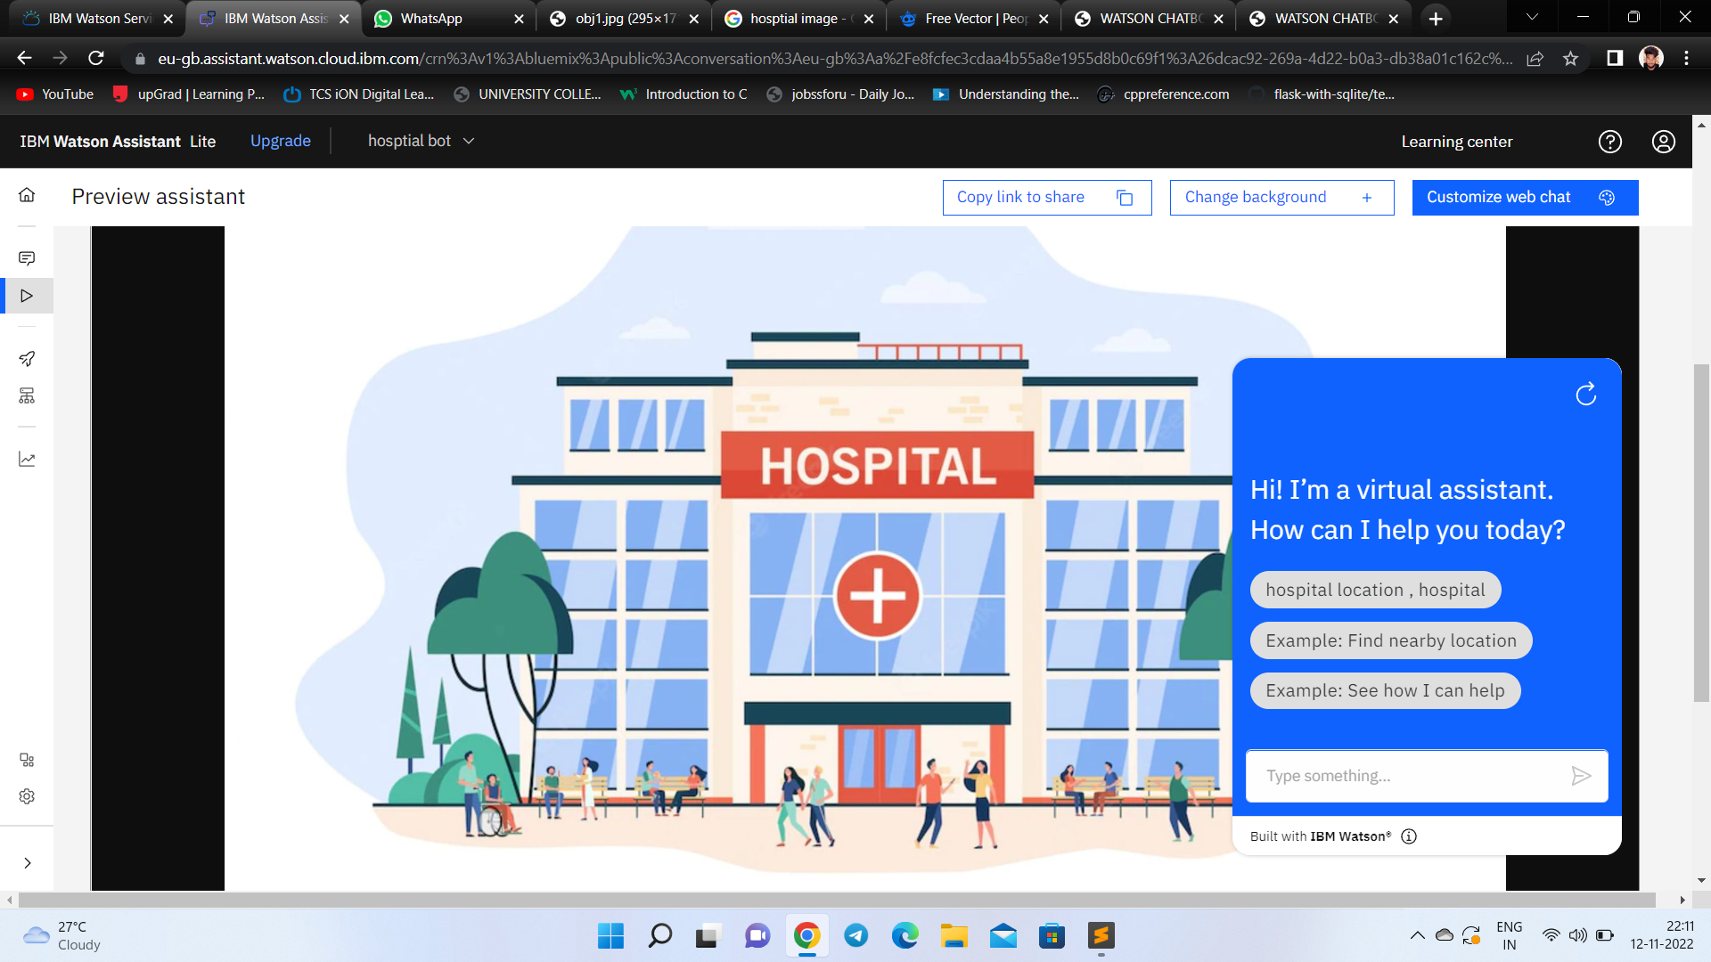<https://web-chat.global.assistant.watson.appdomain.cloud/preview.html?backgroundImageURL=https%3A%2F%2Feu-gb.assistant.watson.cloud.ibm.com%2Fpublic%2Fimages%2Fupx-26dcac92-269a-4d22-b0a3-db38a01c162c%3A%3Ac46309b1-a21e-453e-a3b9-cd1635a49254&integrationID=04c45f60-a19b-4baf-bd3b-5f9170e046e7&region=eu-gb&serviceInstanceID=26dcac92-269a-4d22-b0a3-db38a01c162c> click here

RESULT :

